**PROGRAM-2**

**CODE:** 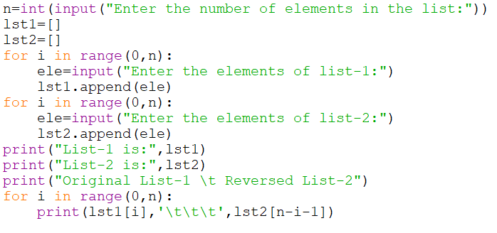

**OUTPUT:** 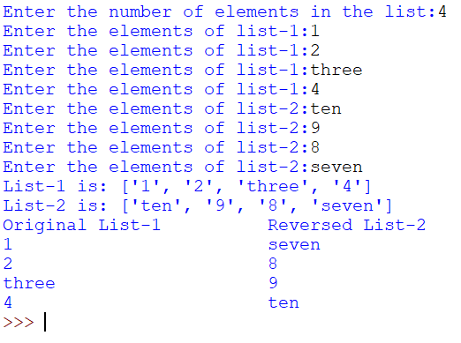

**By:Amogh Garg**

**2020UCO1688**